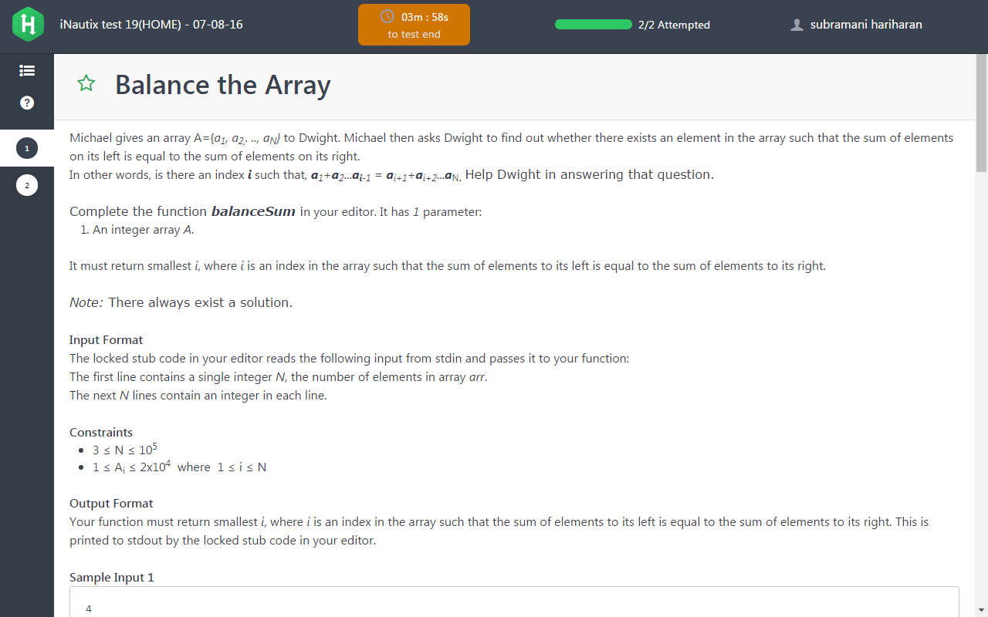

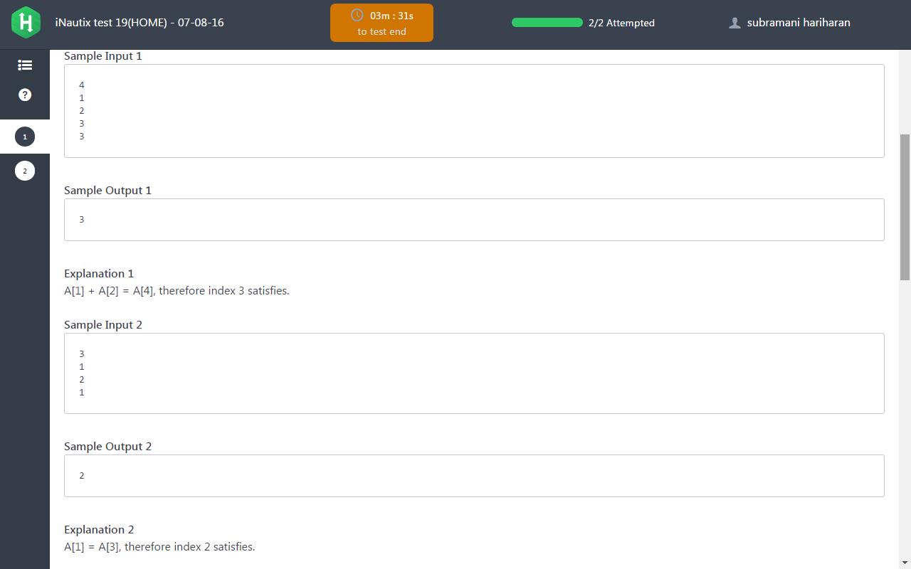

Solution:

int balanceSum(int *A, int length) {

int left_sum=A[0];

int right_sum=0,i;

for(i=1;i<length;i++)

{

right_sum=right_sum+A[i];

}

for(i=1;i<length;i++)

{

right_sum=right_sum-A[i];

if(left_sum==right_sum)

{

return i+1;

}

left_sum=left_sum+A[i];

}

return 0;

}

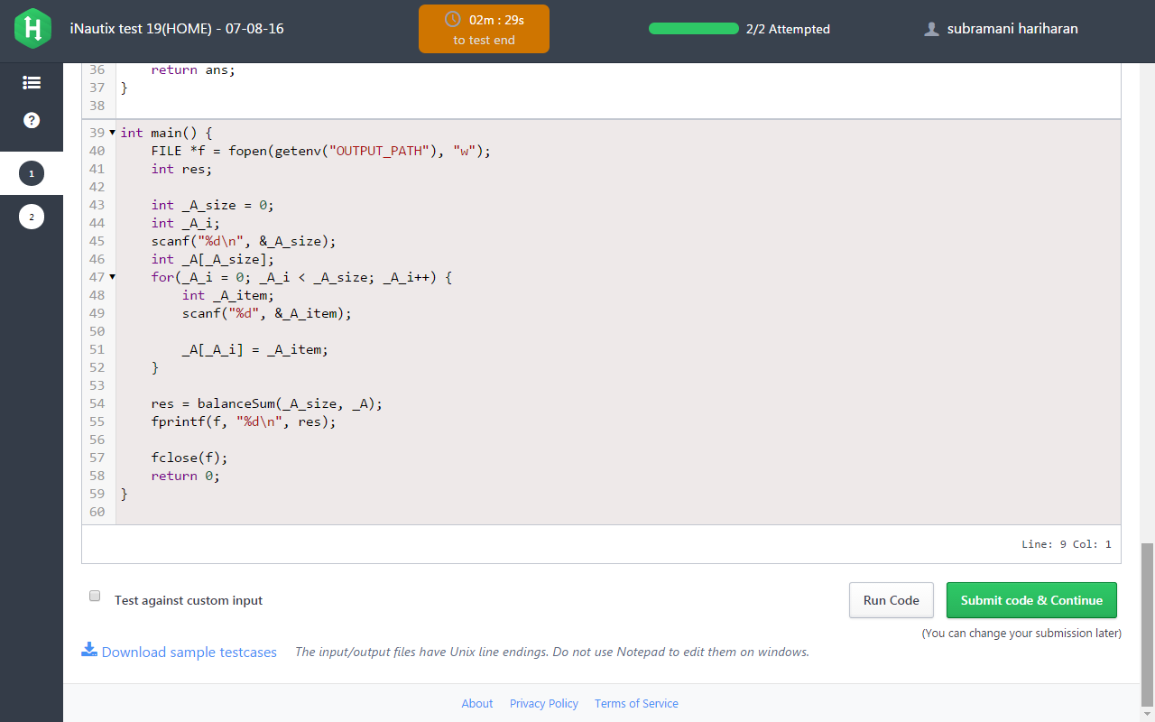

PROBLEM 2:

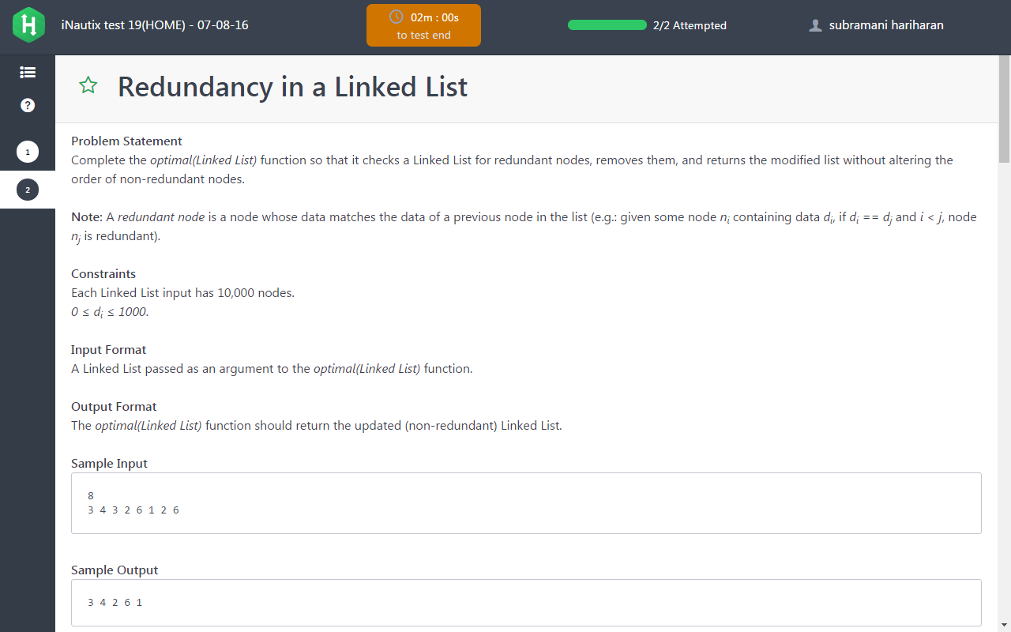

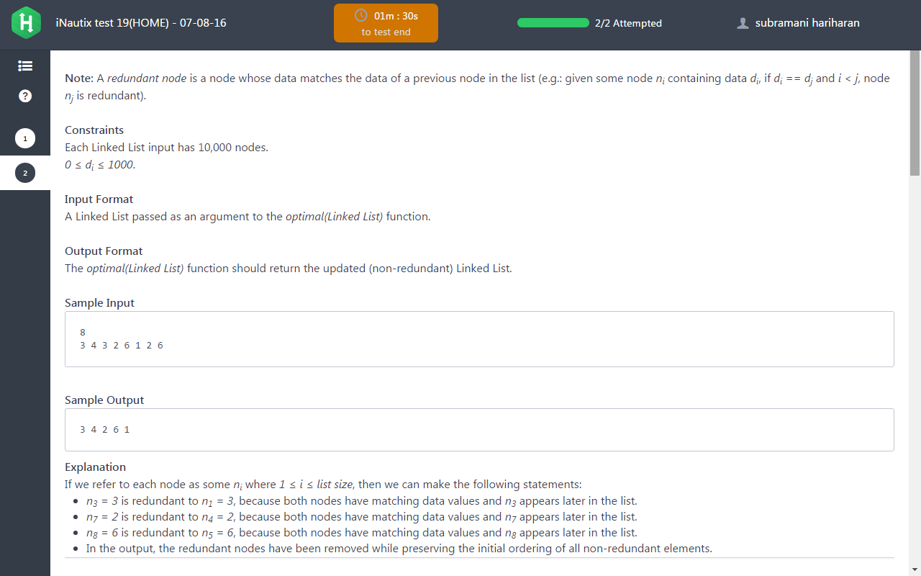

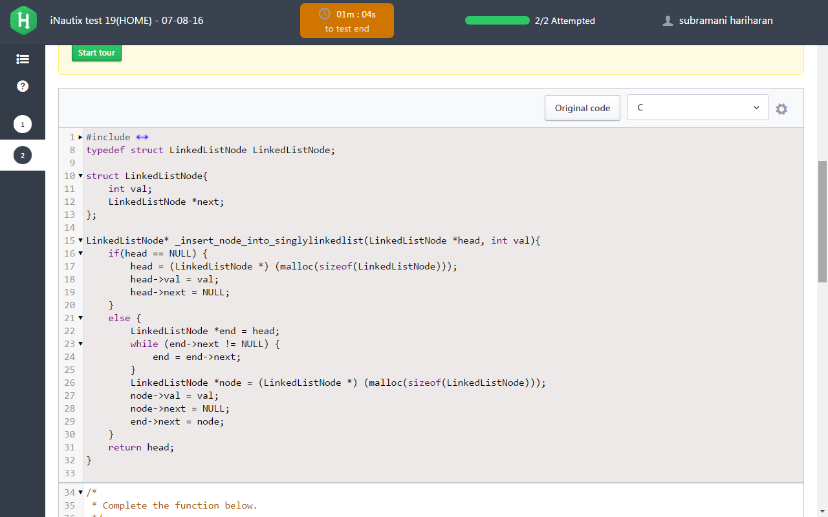

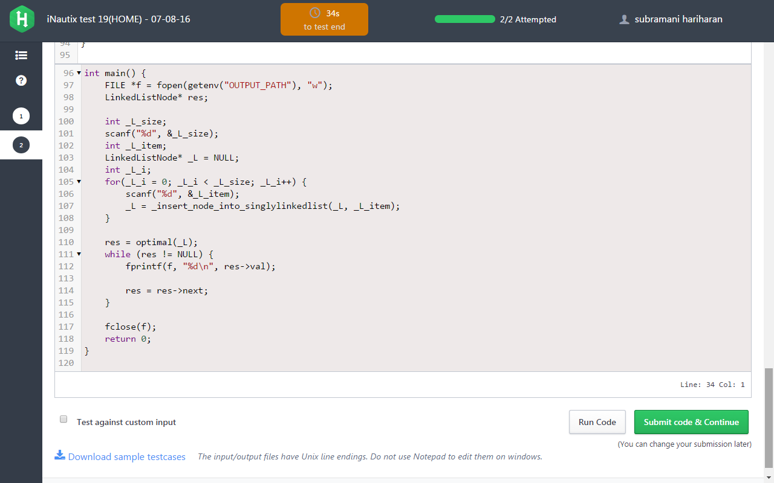

Solution:

/*

* Complete the function below.

*/

/*

For your reference:

LinkedListNode {

int val;

LinkedListNode *next;

};

*/

LinkedListNode* optimal(LinkedListNode* L) {

LinkedListNode *head=L;

int flagship=0;

int nodes[1000]={0};

while(head!=NULL)

{

if(flagship==0)

{

int temp=head->val;

nodes[temp]=1;

flagship=1;

}

else

{

if(head->next!=NULL)

{

int temp=head->next->val;

if(nodes[temp]==1)

{

head->next=head->next->next;

}

else

{

nodes[temp]=1;

head=head->next;

}

}

else

{

return L;

}

}

}

return L;

}